Curriculum Vitae

Personal Details

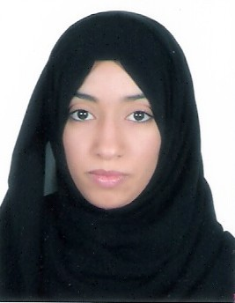
Name: Fatima Abdul Ameer Saeed Marhoon
Nationality: Bahraini.
Date of Birth: 9th November 1987.
C.P.R Number: 871110342.
Marital Status: Married.
Address: House 1089-Road 3827 - Diraz 538.
Tell. Numbers : (+973) 33022696
Email: nadamybaby@hotmail.com

Objective

To work for an organization that will give me the opportunity to learn, develop and contribute to the organization.
Key Experience
I have been study in Secondary Certificates Commerce School, and I gain good experience in Accounting, Marketing, Business Administration and Banking Finance in University of Bahrain after I finished studding the BS.C accounting. Also, I have good experience in using Computer and internet.
Educational Qualifications

[2005 – 2010] University of Bahrain
B.Sc in Accounting
GPA 3.17/4.00

[2002 – 2005] Al Noor Secondary School
Secondary Certificates, Commerce
GPA 95.1/100
Work Experience
[26 Oct ,2011– 12 Jun, 2012] Working at Kumon as Office Assistant

Training/summer jobs

[1 March – 30 April, 2010] Training course in Ministry of Health.
I have just worked there for two months and I learned very quickly. I worked in many departments like cash, insurance and account department. I learn how to use orcal program, making deposit, approve the order, dealing with files and making insurance for company.

Additional Skills

- Computer Skills: MS Office and using internet.
- Interpersonal Skills: Have the ability to learn fast and work in any environment.
- Languages: Good command in spoken and written Arabic and English.

Interests and Activities
- Surfing the Internet.
- Enjoy watching programs which will help me to increase my general knowledge.

References

References provided on request.

Should You Require Any More Information Please Do Not Hesitate To Let Me Know,
I Would Be Glad To Present Myself For Any Interview With You.

